

**Advanced Simulation Modelling 234061-0723**

**CASE STUDY - MACHINES AND TOOLS**

**Homework**

Prepared by:

**Nazarii Melnyk, 83471**

13.05.2020

Warsaw 2020

**Table of contents**

1. Summary

2. Introduction

3. Problem statement

4. Findings

5. Sensitivity analysis

6. Conclusion

7. References

**1. Summary**

This report was created based on Case Study №2 - MACHINES AND TOOLS from subject Advanced Simulation Modelling (234061-0723).

The goal of this report was to test two scenarios for repairing tools transportation time and decide which is more optimal for the company to use.

The result of comparing two tools transportation time models shows that the model S is more preferable to use for the company in terms of saving the budget.

**2. Introduction**

I have the following data for this task:

* 6 machines
* 5 repair tools
* trouble-free operation time for the machine ~ Exponential Dist with exp = 75min
* tools transportation time
  + 1st scenario: 𝑡𝑖=𝑖∗2
  + 2nd scenario: 3 minutes
* repair time ~ Erlang Dist with k=3 and exp = 15 minutes

The project task is to create two models based on above data and find which tools transportation time scenario is the best by calculating both of them.

**3. Problem statement**

According to the task we have 6 machines and 5 repair tools for our model. Each machine can operate for average 75 minutes and after that time it needs to be repaired. Repair time for each machine is 15 minutes in average.

Each repair tool has transportation time. Transportation time is the time which is needed for repair tool to go from repair storage to the broken machine.

*1st scenario (line system):*

After the machine was repaired, the repair tool goes back to the storage. If there is no available repair tool at the moment, the broken machine goes to the queue and wait for the repair tool. Tools transportation time is calculated by given formula:

𝑡𝑖=𝑖∗2

It means that, for example, repair tool spends 2 minutes to go to the machine №1, and 12 minutes to get to the machine №6.

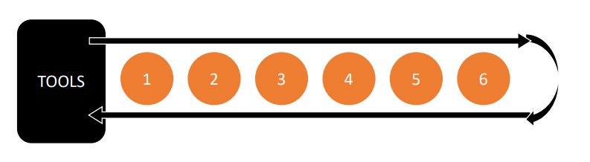

*Picture 1. The visualization for the 1 scenario*

*2nd scenario (star system):*

The repair tools are located inside and the machines are located outside and every time each machine gets broken it gets immediately repaired. If there is no available repair tool at the moment, the broken machine needs to wait in the queue. Tools transportation time is equal to 3 minutes.

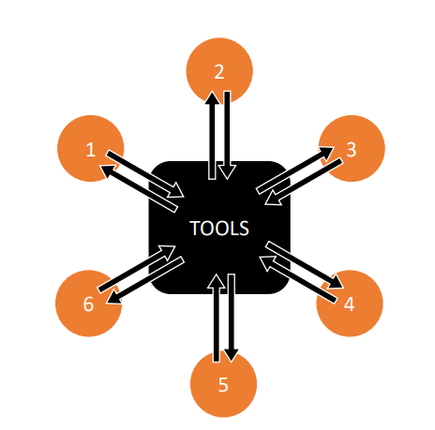

*Picture 2. The visualization for the 2 scenario*

Important thing to notice is that there are always less repair tools than the machines. It means that for both scenarios, it is always the situation that some machines need to wait in a queue to be repaired.

**4. Findings**

My simulation models are based on the following events:

* moments of occurrence of subsequent events
* machines status:
  + W - operating
  + Q - waiting for the tools
  + R - is being repaired
* inactivity time

Event here are the vectors which are designed to control the simulation state.

After creating the models, I received the below results:

The average inactive time for the machines for the 1 scenario (Line system) = 9736 minutes;

The average inactive time for the machines for the 2 scenario (Star system) = 8235 minutes.

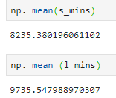

*Picture 3. The mean of inactive minutes for the machines*

**5. Sensitivity analysis**

In this section I am going to see what will happen if key simulation parameters get changed or if some assumptions are not met.

The base model was created using the exponential distribution. I will change it to gamma distribution to see what effect it may have for the models L and S.

Another parameter which I am going to add is the cost of 1 minute when the machine is inactive and compare this values between models L and S. I assume that this will help me to choose which model is more efficient in terms of budget saving.

Let’s calculate and compare the probable loss for models L and S based on exponential distribution firstly.

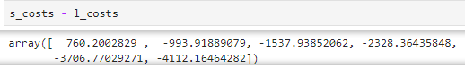

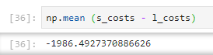

*Picture 4. The output for the exponential distribution*

Based on above output I can see that using model S will save in average 1987$ for the company’s budget (with exponential distribution).

Now I will change the distribution to gamma and see if there is any changes for the model.

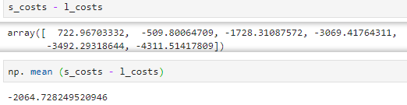

*Picture 5. The output for the gamma distribution*

Based on above output I can see that using model S will save in average 2065$ for the company’s budget (with gamma distribution).

**6. Conclusion**

The goal of this paper was to create and compare two models based on the data provided by Case Study. Models were created to compare the Line and Star tools transportation time systems and interpret the results for the company’s finance team.

It is less inactive minutes for the machines using model S (9736 min > 8235 min).

What is more, I can see that company may save ≈ 2000$ using the model S tools transportation time.

As a conclusion, I can say that model S is more preferable to company in terms of saving the budget.

**7. References**

The Case Study MACHINES AND TOOLS from the Advanced Simulation Modeling class (234061-0723).